USER CENTERED DESIGN (UCD) AND PROTOTYPING
User-centered design (UCD) is a product development philosophy focusing on the needs, wishes, and constraints of end-users at all stages of the design and development cycle. Products developed using the UCD method are optimized for end-users and include them in the development process. In user-centered design, it is important to understand how consumers must or want to use a product, rather than forcing them to adapt their behavior for using it.
User-centered design takes into account age, gender, social status, education and professional background, influential factors, product usage expectations and demands and many other important things that may vary for different segments. What is critical for some may be irrelevant for others. User-centered design is about deep research on users’ habits, from their interactions with the product to their vision of how the product should look like and behave.
Principles of UCD
There are five major UCD principles:
- The design is based upon an explicit understanding of users, tasks and environments.
- Users are involved throughout design and development.
- The design is driven and refined by user-centered evaluation.
- The process is iterative
- The design addresses the whole user experience
- The design team includes multidisciplinary skills and perspectives
(i) Explicit understanding of users, tasks, and environments - Most of the analysis in current practice focuses on processes, not people. We can improve our results by understanding what people are thinking and how they feel when they are completing a task.
(ii) Involvement of users throughout the design and development - Early input is necessary, but it is not the end. User involvement should continue throughout the process.
(iii) User-centered evaluation driven/refined design - The people who do the work should be the ones who review and test the software. The standard should be that the user can complete the task without instruction the first time they do it. A better standard would be that the user feels a sense of accomplishment.
(iv) Iterative process - Testing new processes and configurations begins a cycle of innovation as users discover new possibilities. Expect and welcome changes as people work through the process.
(v) Consideration of the whole user experience - The user experience begins at the moment each becomes aware of an impending change. Change management and communication should start at the moment you decide you need a change. The ideal first communication is when you ask people about the current state and what they would do to change it.
(vi) The adoption of multidisciplinary skills and perspectives - Most human capital technology decisions are made by a tiny group of HR and IT people. We can do better by engaging every discipline in the organization from the very start of the project. Each part of the organization has its view of how things should work. Any process that leaves them out creates a potential point of resistance.

USER METHODS IN USER CENTERED DESIGN

1. User Research

User research is about gathering users wants and needs. It is crucial to collect abundant user data to direct your design to be more user-centric.
- Who are you designing solutions for?
- What are their problems (pain points)?
- How do they currently complete tasks?

2. Experience Map

Experience mapping is about turning piles of user research observations into outlines of user’s tasks and pain points. It helps to extract pain points, goals and persona information and highlight the order of the actions and the pain points users experience.
3. Personas
A persona represents an aggregate of target users who share common behavioral characteristics (i.e., is a hypothetical archetype of real users). A persona is represented through a fictional individual, who in turn represents a group of real consumers with similar characteristics. Even though a persona is not a real person, a name and a picture are selected to represent the fictional representative. Second, a persona is described in narrative form. This narrative has two goals:
- To make the persona seem like a real person, and
- To provide a vivid story concerning the needs of the persona in the context of the product being designed.
The narrative of a persona starts with a description of the type of individual that the persona is, likes and dislikes, occupation, and so forth. This part of the narrative brings the persona to life. Then, the persona’s specific needs and personal goals in the context of the product being designed are described. This segment of the narrative helps to inform the resulting design decisions. These are the same needs that one would find in a standard requirements document but are now written in the context of the narrative describing a specific persona.

4. User Scenarios
A user scenario is the fictitious story of a user’s accomplishing an action or goal via a product. It focuses on a user’s motivations, and documents the process by which the user might use a design. User scenarios help designers understand what motivates users when they interact with a design – a useful consideration for ideation and usability testing.
A fundamental point to bear in mind is that user scenarios do not represent all possible users. Instead, they typically account for only the most common users or user motivations. It is therefore common for user scenarios to be based on user personas. Good user scenarios provide context and detail in order to be as accurate and relatable as possible. So as to represent target users in the truest form possible, user scenarios need to be based on some form of insight into or research done with real or prospective users. Consequently, by working through well-thought-out user scenarios populated with valid user personas, a design team will be able to project a stronger light on their work in progress and expose previously obscure problem areas, which they can then remedy.

5. Ideation Sketches
This technique involves members of the design team and potential users, producing sketches or designs of the ideas that they wish to input to the design process. The objective is to enhance user participation in the design process and collaboration between designers and users. The easiest way to set up a sketching exercise is to use a flipchart or whiteboard with everyone sitting around it presenting and reacting to ideas. An electronic whiteboard has the advantage of producing printouts of the screen which can then be photocopied to the group before rubbing out the earlier ideas to consider new ones. Alternatively, users may sketch their own ideas individually which they can then each present in turn to the group.
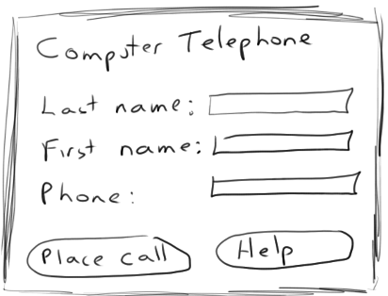
6. Storyboarding
These provide rough sketches of what the system will look like and are good for predominantly graphical interfaces and websites. They are cheap to produce and easy to change! You will find that you will also need a 'map' showing how the 'narrative.' of the storyboard runs. Storyboard narratives should be produced that show how the sketches relate to one another.
As already indicated, the term 'prototype' does not even need to mean a’ piece of software. Storyboarding is an example of prototyping done using pen-and-paper sketches. The idea comes originally from drama design in TV' and theatre. A writer would express an idea for a scene by showing a series of drawings depicting the characters, a set, and a sequence of verbal dialogue and physical movement. This simple paper-based expression of ideas could encompass a number of issues on dialogue, set design, costume, choreography and so on without committing any physical resources.
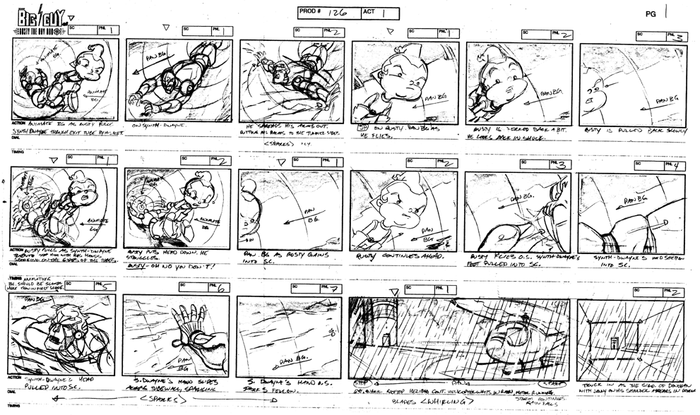
It is, therefore, a cheap and rich way of expressing an idea. Likewise, this approach helps system designers to demonstrate design ideas without even the need for a simple throwaway prototype. Despite being paper-based, aspects of navigation, screen design, feedback and feature representation can all be analyzed with this technique.
7. PICTIVE ( Plastic Interface for Collaborative Technology Initiatives through Video
Exploration)
PICTIVE increases user participation in the design of computer interface. PICTIVE consist of brainstorming with low-level object to communicate ideas between design team members. In these video-taped sessions, users and designers physically construct and manipulate “objects” on a clean surface representing a blank computer screen. Pre-prepared or spontaneously created objects are made from paper, colored paper transparencies, post it notes, paper clips, colored markers etc. are used to represent work/job tasks engaged in by the user and typical “system” objects such as dialogue boxes, etc. and menu bars. The pictive technique enable users within no computer skills to actively participate in the design of prototype.
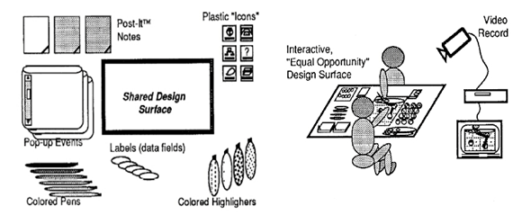
8. CARD ( Collaborative Analysis of Requirements and Design)
Similar to PICTIVE but at a higher level of abstraction: explores work flow not detailed screen design.Uses playing cards with pictures of computers and screen dumps
Similar structure to the session as for PICTIVE. The CARD technique is a game-like procedure through which a diverse group can lay out, design, or critique a task flow or activity flow. The materials in the CARD technique are physical playing cards, each of which represents a work activity, an object in the workplace, a person, an interpersonal activity, or a mental operation or state . Cards are printed on colored cardstock; the colors are used to indicate a high-level class hierarchy, with related cards printed in the same color.
CARD sessions are conducted informally as a kind of semi structured brainstorming session. Participants are people who want to combine their different to reflect their diverse workplace needs and constituencies.
CARD | PICTIVE
CARD uses playing cards with pictures of specific items on them | Prototyping method uses low-fidelity office products, such as pens paper and sticky notes. The actions of the users are videotaped.
CARD looks at the flow of the task, just as storyboarding | Concentrates on the detailed aspects of the system
CARD giving a Macroscopic view of the task flow | PICTIVE giving the microscopic view.

9. Scripted simulations
Scripted simulation involves creation of storyboard with media tools. Each scene transition is activated by simple user inputs. A user is given a very tight script/task to follow. It should appears to behave as a real system since script deviations blow the simulation.
10. Interface builders
Interface Builder provides palettes, or collections, of user interface objects. These user interface objects contain items like text fields, data tables, sliders, and pop-up menus. Interface Builder's palettes are completely extensible, meaning any developer can develop new objects and add palettes to Interface Builder.
To build an interface, a developer simply drags interface objects from the palette onto a window or menu. Actions (messages) which the objects can emit are connected to targets in the application's code and outlets (pointers) declared in the application's code are connected to specific objects. In this way all initialization is done before runtime, both improving performance and streamlining the development process.
11. Tutorials and Manuals
Tutorial allow user to work through basics of an application within a test environment. The user can progress at his own speed and can repeat parts of the tutorial if needed. He will also get a feel for how application works by experimenting with examples, albeit small ones, or by watching an automated demonstrated of how to perform a task.
Manuals provide a full description of the system functionality and behavior is systematic manner.

PHASES OF THE USER-CENTERED DESIGN PROCESS
User-centred design can be characterized as a multi-stage problem solving process that not only requires designers to analyse and foresee how users are likely to use a product, but also to test the validity of their assumptions with regard to user behavior in real world tests with actual users at each stage.
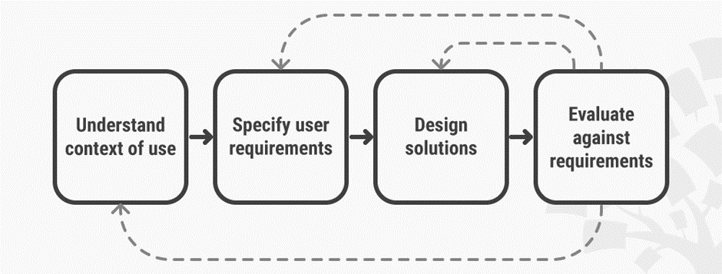

The following are the general phases of the UCD process:
- Specify the context of use: Identify the people who will use the product, what they will use it for, and under what conditions they will use it.
- Specify requirements: Identify any business requirements or user goals that must be met for the product to be successful.
- Create design solutions: This part of the process may be done in stages, building from a rough concept to a complete design.
- Evaluate designs: Evaluation - ideally through usability testing with actual users - is as integral as quality testing is to good software development.
PROTOTYPING
Prototypes are ideally based on the machine rather than on paper and are therefore closer to the look and behaviour of the intended system. They consist of user interfaces that seem to look and behave like a complete system. However, it is important to remember that they only need to go this far and need not actually function like the real system. For example, if we are prototyping a system involving database searching we do not need to have an actual database behind the interface. All we need is an appropriate response to user input. So if a user tests a system by putting data in, the system can output what appears to be the result of a database search but is actually a pre-prepared response. The important thing is that the prototype appears to behave as the intended system would behave. Prototypes elicit information about functionality, the operation of individual features, sequences of operations, and the general 'look and feel'.
TYPES OF PROTOTYPE
1. Throwaway: sometimes the prototype as a physical program is not intended to develop into the final software program - but the design ideas that emerge from its evaluation are carried forward to influence the final requirements statement and design. Typically, the prototype will consist of a front-end that is partially functional, but may simply mimic the behaviour of a system. For example, the user can test a database front-end to a database that is not yet built. The prototype designer simply designs the search input and results output to behave as the finished system would behave. This means usability considerations relevant to the design of those databases can be discovered prior to their final design and build
2. Evolutionary: this has a similar developmental role to 'throwaway' in that it helps to refine understanding and validate aspects of design, but the software program is retained and developed. The prototype has functionality added incrementally as more design aspects are added, tested and refined
4. Incremental: in this example the system is built as separate components. The final product is then released as a series of components, each release adding a component until the complete product is delivered.

TECHNIQUES USED IN PROTOTYPING
- Rapid prototyping: This is becoming increasingly popular, involving a very quick computer-based simulation of the look and feel of a system using a common application such as MS Word or MS PowerPoint. If you are familiar with Latex, that is particularly useful, as it tends not to change in appearance when moved from one machine to another.
- High-fidelity versus low-fidelity: high-fidelity prototyping refers to prototypes that have practically all the functionality that the intended system would have. Therefore, the user is able to test the range of relevant usability aspects. It also has the advantage that users do not need to be directed in which features they try to use, as they do in prototypes where only a small percentage of the functions are active. However, high-fidelity prototypes are expensive and time-consuming to develop: they are often unnecessary, as more low-fidelity prototypes can be introduced at different stages as the specification of design develops. Low-fidelity prototypes are only partially functional, are much cheaper to develop, and can provide feedback into the design process.
- Horizontal and vertical prototypes: when designing prototypes, we must carefully consider what elements of functionality should be included or omitted. One particular issue is whether we need to emphasise depth or breadth. Horizontal prototyping provides a wide range of functions, but in a relatively superficial way With the user. This may be suitable for testing the user's ability to recognise a large range of features from their labels. The other approach is vertical prototyping. In vertical prototyping only a small subset of the system's functionality is active, but that functionality has greater depth of detail. This is useful in a system that supports a large number of similar actions
- Wizard of Oz: the 'Wizard of Oz' technique tests prototypes by connecting one machine (on which the prototype is shown to the user) to another (that is controlled by a design team member) This makes it seem to the user that it is fully functional when, In fact, the team member is controlling system output and responses. The user interacts with the interface, for example sending queries to a database or help system. The designer, unseen by the user, then produces a response that looks to the user like a response from the system. The overall objective of making the experience authentic and seem real for the users may allow further techniques. For example, imagine we want to test the design of an auditory menu for a phone-based system.
Our test users would simply try to interact by telephone to what they will take to be a long-distance recipient. However, the role of the 'auditory menu' is not played by an electronic voice synthesizer, but by a design-team member, speaking responses from the next room. The same effect is achieved, but it is so much easier and cheaper .
- Limited functionality simulation: as we mentioned earlier, it is not necessary for prototypes to be fully functional. The important thing is that the users who test it get the experience that they would get if this were the real design. So it is enough for them to think they are interrogating a database (which is not there) simply because you have produced a page that seems to bear search results in advance, and it appears at the point in the interaction when the user would expect it. Also, your credit card payment mechanism may not exist, but your user can still put card details into a payment form and submit, and the system can respond. So the user tells you if your form is complicated, if the feedback is adequate after the submit action, or if the interface made them feel confident that the transaction was secure.

